SmartCare Referral Workflow
This process does not apply to FSP referrals, AOT referrals, Child Welfare referrals
Sending a referral:
- Create a new message in SmartCare
  - How to Send a Message - 2023 CalMHSA
- Utilize the “Referring Staff Message Template” to guide you on the content of your referral message.
Referring Staff Message Template:
- Select person served who is the subject of the referral
- Select designated staff from the team you are referring to
- Priority (select one): Normal, Caution/Alert, Urgent
- Make message part of client record: check this box
- Subject: Referral to [insert name of program you are referring to]
  - Ex. Referral to Turning Point Rural- Kerman Clinic
- Information for text box (copy/paste template below):
  - School Name (youth only):
  - District Name (youth only)
  - Parent/Guardian Name and Contact Information (youth only):
  - Preferred Language of the Parent/Guardian (youth only):
  - Preferred Language of Person Served:
  - Referring from Program:
  - Referral Reason (select one to include in message): Choose an item.
  - Referral justification, recommended level of care & risk factors:
  - Justification for urgent referral (only include if referral is marked urgent):
- Push envelope icon to send
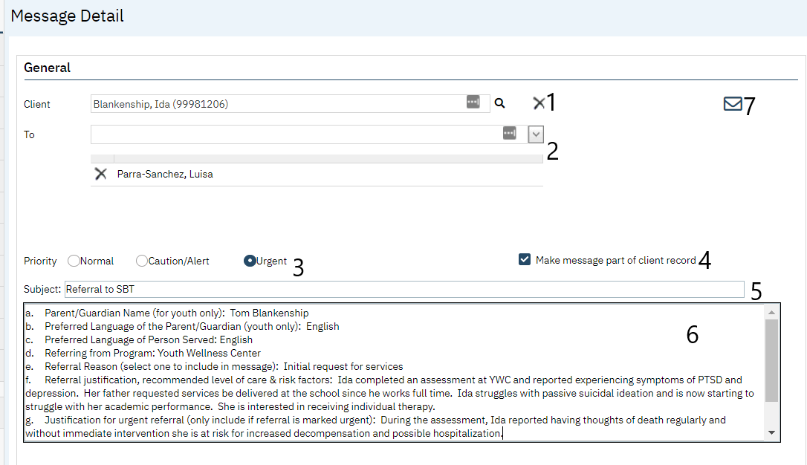

Receiving a referral:
- Open the referral message you received and reply utilizing the “Receiving Staff Message Template” to guide you on the content of your reply.
- After you have sent the reply message open the client program list page and add the client to your program. How to Add the Client to Your Program - 2023 CalMHSA
  - The requested date should be the date the referral message was sent to you.
  - The enrolled date should be the date you are assigning the client to a staff member in your program
Receiving Staff Message Template:
You will need to recheck the “Make message part of the record” box to make your reply part of the client record.
- Review Message Details “To” section to determine how many individuals were included on the original message
  - If more than one individual was included you will need to add their name for them to receive the reply
- Information for text box (copy/paste template below):
  - Approval Status: Choose an item.
  - Approved/Denied Comments:
- Push envelope icon to send
Example:
